Question 1 : . Add a 10GB disk to the CentOS



Question 2 : Create 2 Partitions 4GB and 6GB of Space respectively.

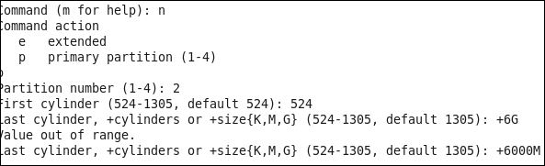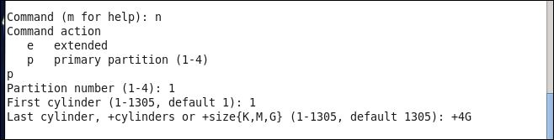

Question 3: . Format 4GB with xfs and 6GB with ext4 file system.



4. Mount 4GB and 6GB in /data and /music directory respectively.

